# Admin Panel

# Created on May 23, 2020

1. **List of Features:**
2. List information about users signed up on the website.
3. List all the information about sales and other company related projects.
4. List all the tasks to be done.
5. List recent customer activity.

These features make the backend for any commercial website and help to track the website progress easily. This is what helps an ecommerce website lookout for its sales. This panel is not accessible to normal user. This is accessible only by admins.

1. **Design and Implementation:**

In this project, I moved from one step to the next.

1. Creating navbar.
2. Creating header.
3. Creating cards.
4. Creating tables.
5. Creating charts.
6. Once the basic structure was ready then applied a bit of CSS.
7. In the end created a footer.
8. Added tooltips on edit and delete on taskbar
9. Made some little creative changes.
10. Made the site responsive.

The only framework included in this project is Bootstrap and also jQuery was used for applying toolkit.

**Bootstrap** is the most popular HTML, CSS, and JavaScript framework for developing responsive, mobile-first websites.

Bootstrap is completely free to download and use!

Bootstrap is a free and open-source CSS framework directed at responsive, mobile-first front-end web development. It contains CSS- and (optionally) JavaScript-based design templates for typography, forms, buttons, navigation, and other interface components.

**jQuery** is a JavaScript library designed to simplify HTML DOM tree traversal and manipulation, as well as event handling, CSS animation, and Ajax. It is free, open-source software using the permissive MIT License. As of May 2019, jQuery is used by 73% of the 10 million most popular websites.Web analysis indicates that it is the most widely deployed JavaScript library by a large margin, having 3 to 4 times more usage than any other JavaScript library.

jQuery's syntax is designed to make it easier to navigate a document, select DOM elements, create animations, handle events, and develop [Ajax](https://en.wikipedia.org/wiki/Ajax_(programming)) applications. jQuery also provides capabilities for developers to create plug-ins on top of the JavaScript library. This enables developers to create abstractions for low-level interaction and animation, advanced effects and high-level, themeable widgets. The modular approach to the jQuery library allows the creation of powerful dynamic web pages and Web applications.

**SCREENSHOTS:**

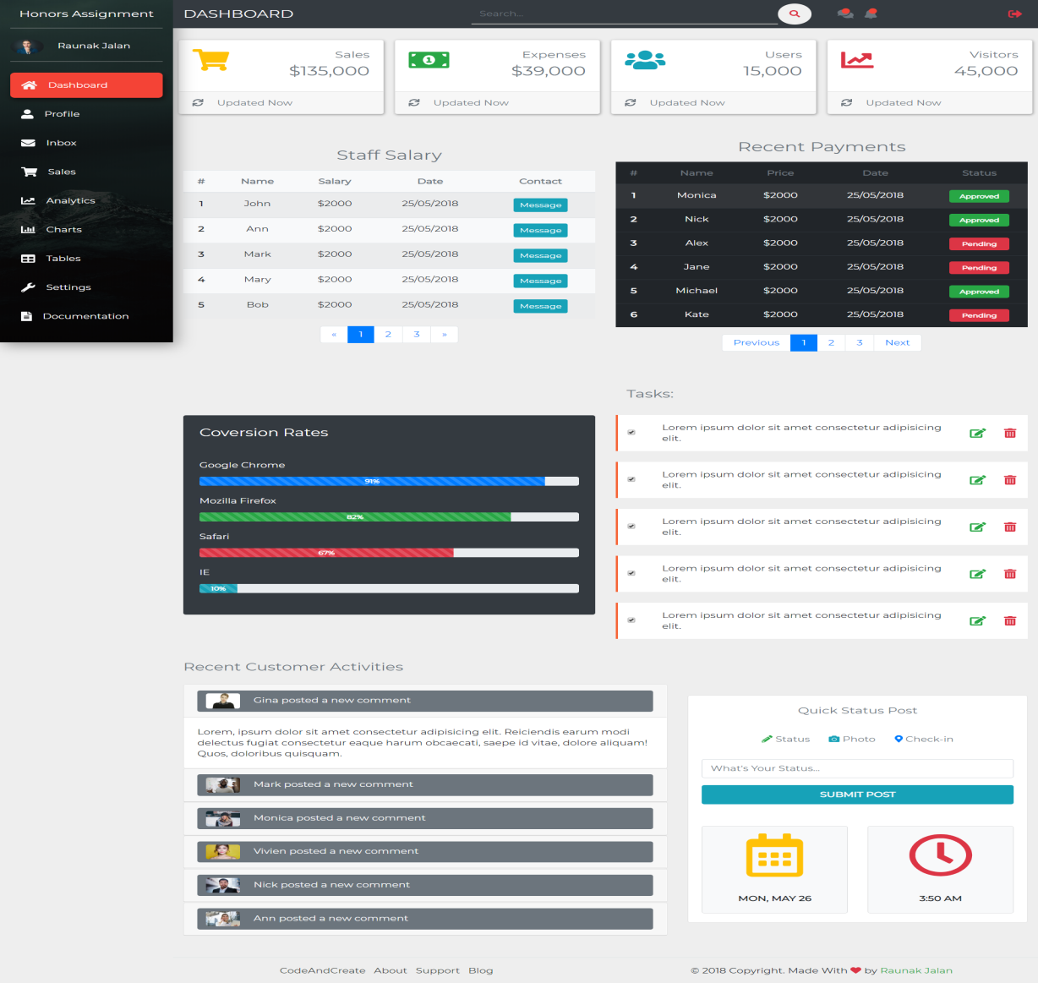

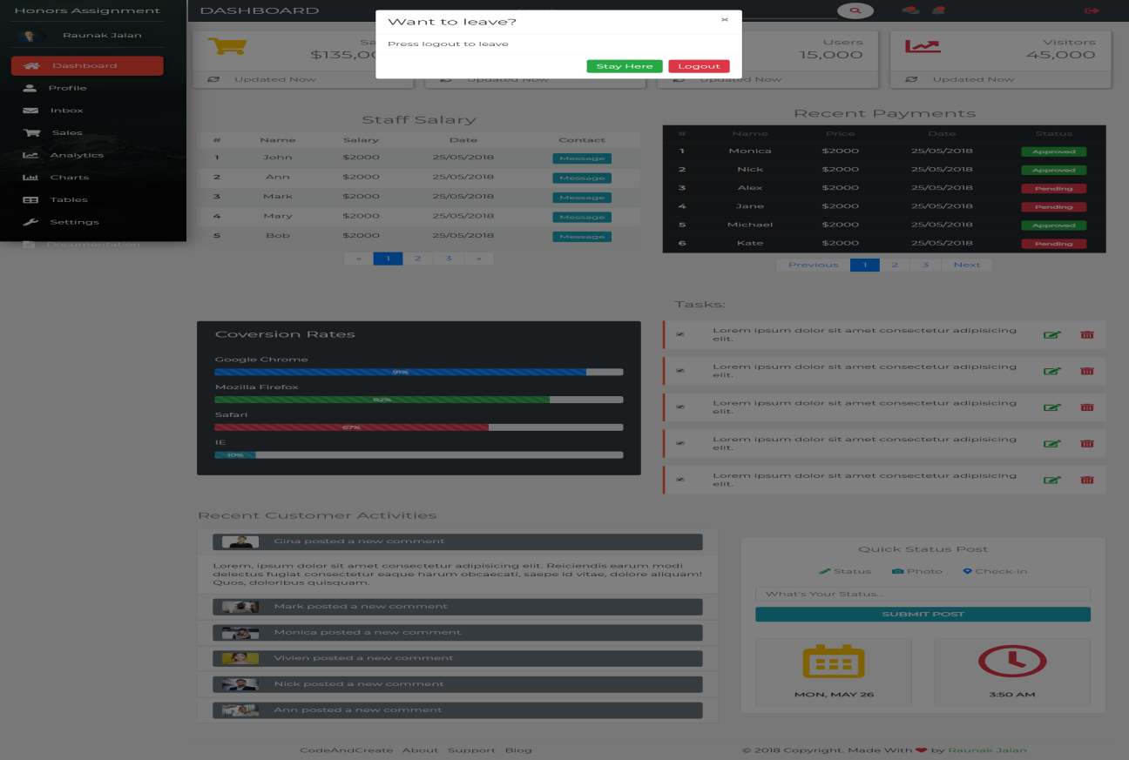

1. **Conclusion:**
   1. This project helped to learn efficient and clean use of bootstrap helps a lot. But even a little mixup can cause a drama in your web page.
   2. Better understood BootStrap.
   3. Shortcoming is that it is not working website. It is just a design.
   4. I would have used SCSS instead of CSS as it would have strengthened my core skills.
   5. Would try to create it from scratch and without use of Bootstrap.
2. **References:**

The Design was picked from here:

https://www.youtube.com/watch?v=XK-H0kQW54Y&t=5027s